

CYBERSTER INTERNSHIP

WEEK 4 REPORT
PRUDENCE NTHENYA

Program: Cyberster Blue Team Internship
Phase: Phase One — SOC Operations and SIEM Foundations
Reporting Period: Days 22 – 28
Subject: pfSense Deployment, Threat Intelligence, and Vulnerability Management

Prudence Nthenya
CSI-B1-479

1. EXECUTIVE SUMMARY
​Week 4 finalized the transition of the lab from a collection of monitored hosts into a structured Security Operations Center (SOC) environment. Key milestones included the deployment of a pfSense virtual firewall to manage network segmentation, the integration of external threat intelligence (VirusTotal and MITRE ATT&CK), and the implementation of automated vulnerability assessment. The week concluded with the development of custom SOC dashboards and executive reporting to communicate security posture to diverse stakeholders.

​2. pfSENSE FIREWALL DEPLOYMENT (DAYS 22-23)
​Objective: Establish a controlled network perimeter by routing all lab traffic through a dedicated firewall.

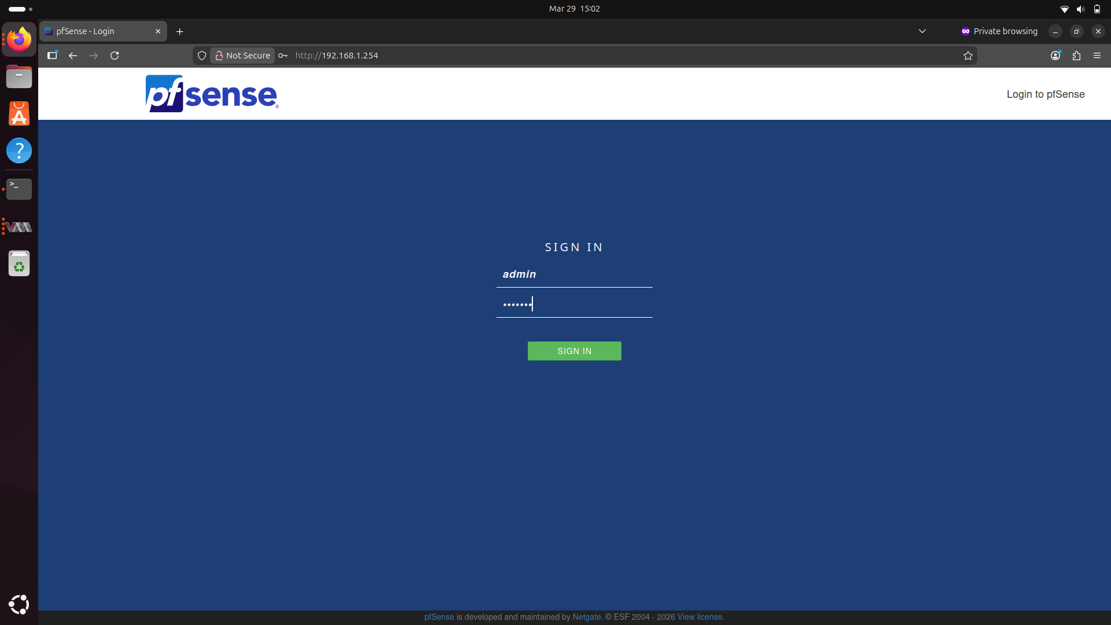
​2.1 Network Topology Realignment
​The lab architecture was shifted from a flat network to a segmented model:
​WAN Interface: Connects pfSense to the external network/internet.
​LAN Interface: Connects to the internal Host-Only network containing the Ubuntu, Windows, and Kali VMs.
​Gateway Configuration: All VMs were reconfigured to use the pfSense LAN IP as their default gateway, ensuring all inter-VM and outbound traffic is inspected by the firewall.
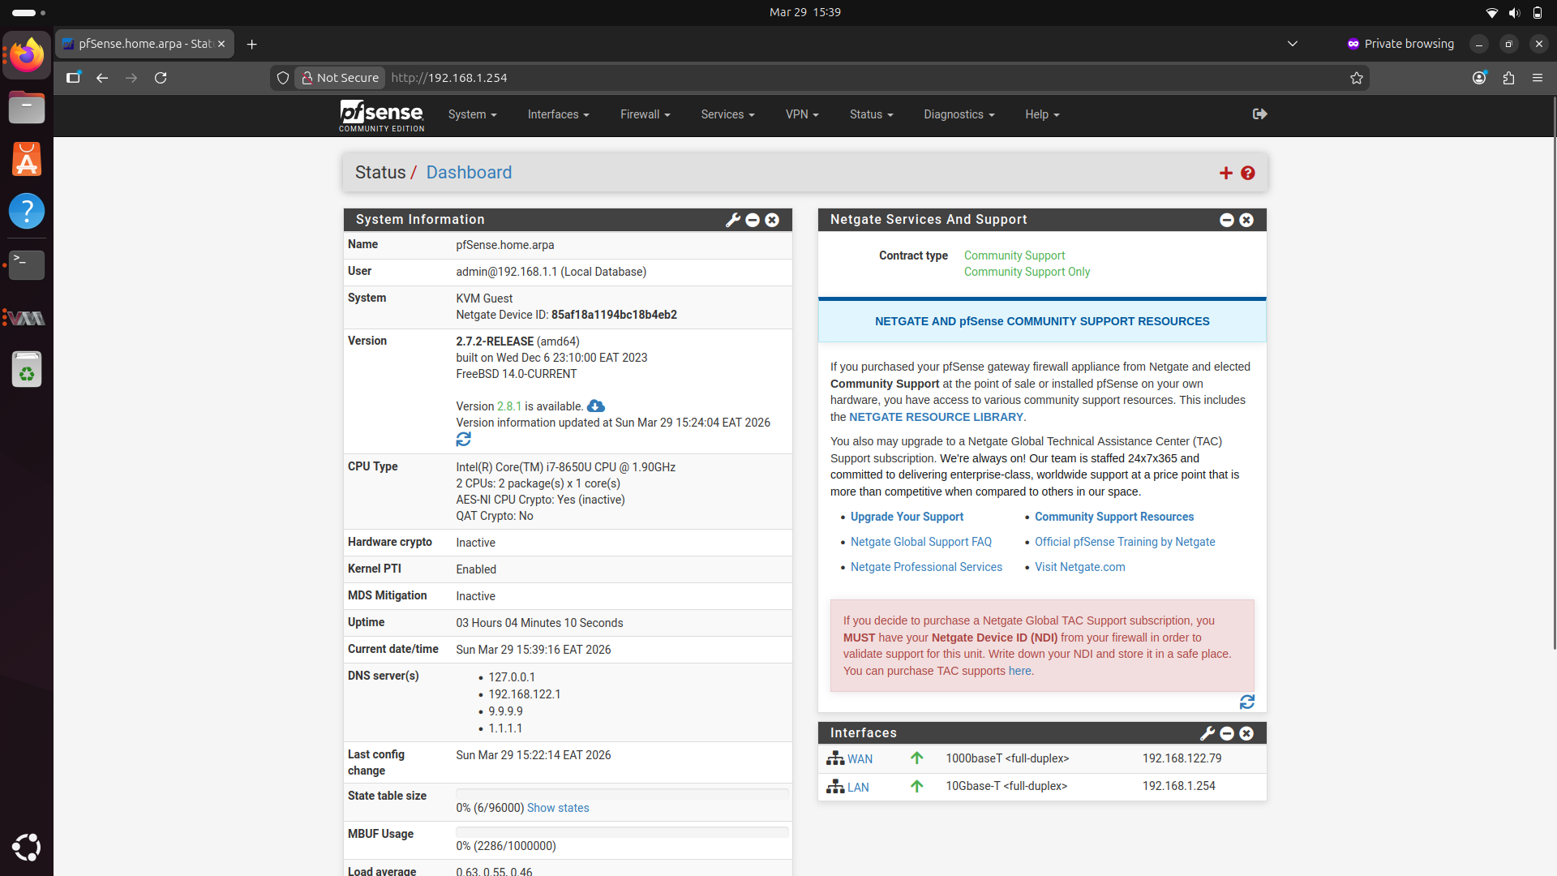

​2.2 SIEM Integration
​Syslog Forwarding: pfSense was configured to export system and firewall logs to the Wazuh Manager via UDP Port 514.
​Visibility: Custom firewall rules were created with logging enabled to track traffic between internal segments, providing "North-South" and "East-West" visibility within the Wazuh dashboard.

​3. THREAT INTELLIGENCE & ENRICHMENT (DAYS 24-25)
​Objective: Enrich raw detection alerts with external context to improve response prioritization.

​3.1 VirusTotal Integration
​Function: Configured the Wazuh Manager to automatically submit file hashes detected by File Integrity Monitoring (FIM) to VirusTotal.
​Outcome: Alerts now include a "malicious" score, instantly identifying if a changed file is known malware.
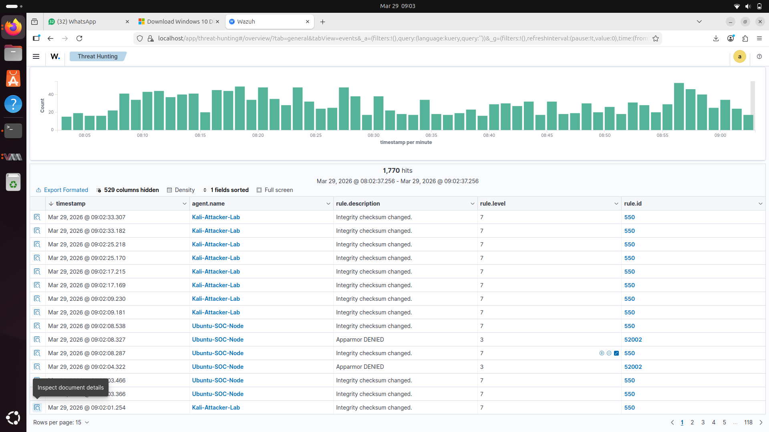
​3.2 MITRE ATT&CK Mapping
​Framework Alignment: Enabled the built-in MITRE ATT&CK module to map alerts (e.g., SSH Brute Force, Nmap scans) to standardized adversary techniques.
​Analysis: Identified at least three techniques (e.g., Brute Force, Network Service Scanning) to visualize the simulated attacker's behavior.
​3.3 Indicators of Compromise (IOC) Lists
​CDB Lists: Implemented Wazuh Constant Database (CDB) lists to store threat feeds from URLhaus and Abuse.ch.
​Active Matching: Rules were authored to trigger alerts when network traffic matches an IP or domain found in these external blacklists.

4. VULNERABILITY ASSESSMENT (DAYS 26-27)
​Objective: Transition from reactive detection to proactive risk management.

​4.1 Automated Scanning
​NVD Integration: Enabled the Wazuh Vulnerability Detection module, which correlates agent software inventory against the National Vulnerability Database (NVD).
​Agent Inventory: Verified that Syscollector was active on both Windows and Linux agents to provide an accurate list of installed packages.

​4.2 Prioritization and Remediation
​CVSS Scoring: Findings were categorized by Common Vulnerability Scoring System (CVSS) scores, prioritizing "Critical" (9.0+) and "High" (7.0+) risks.
​Remediation Loop: A "patch-and-verify" cycle was performed on the Linux agent. After updating a vulnerable package, a rescan confirmed the removal of the associated CVE from the dashboard.

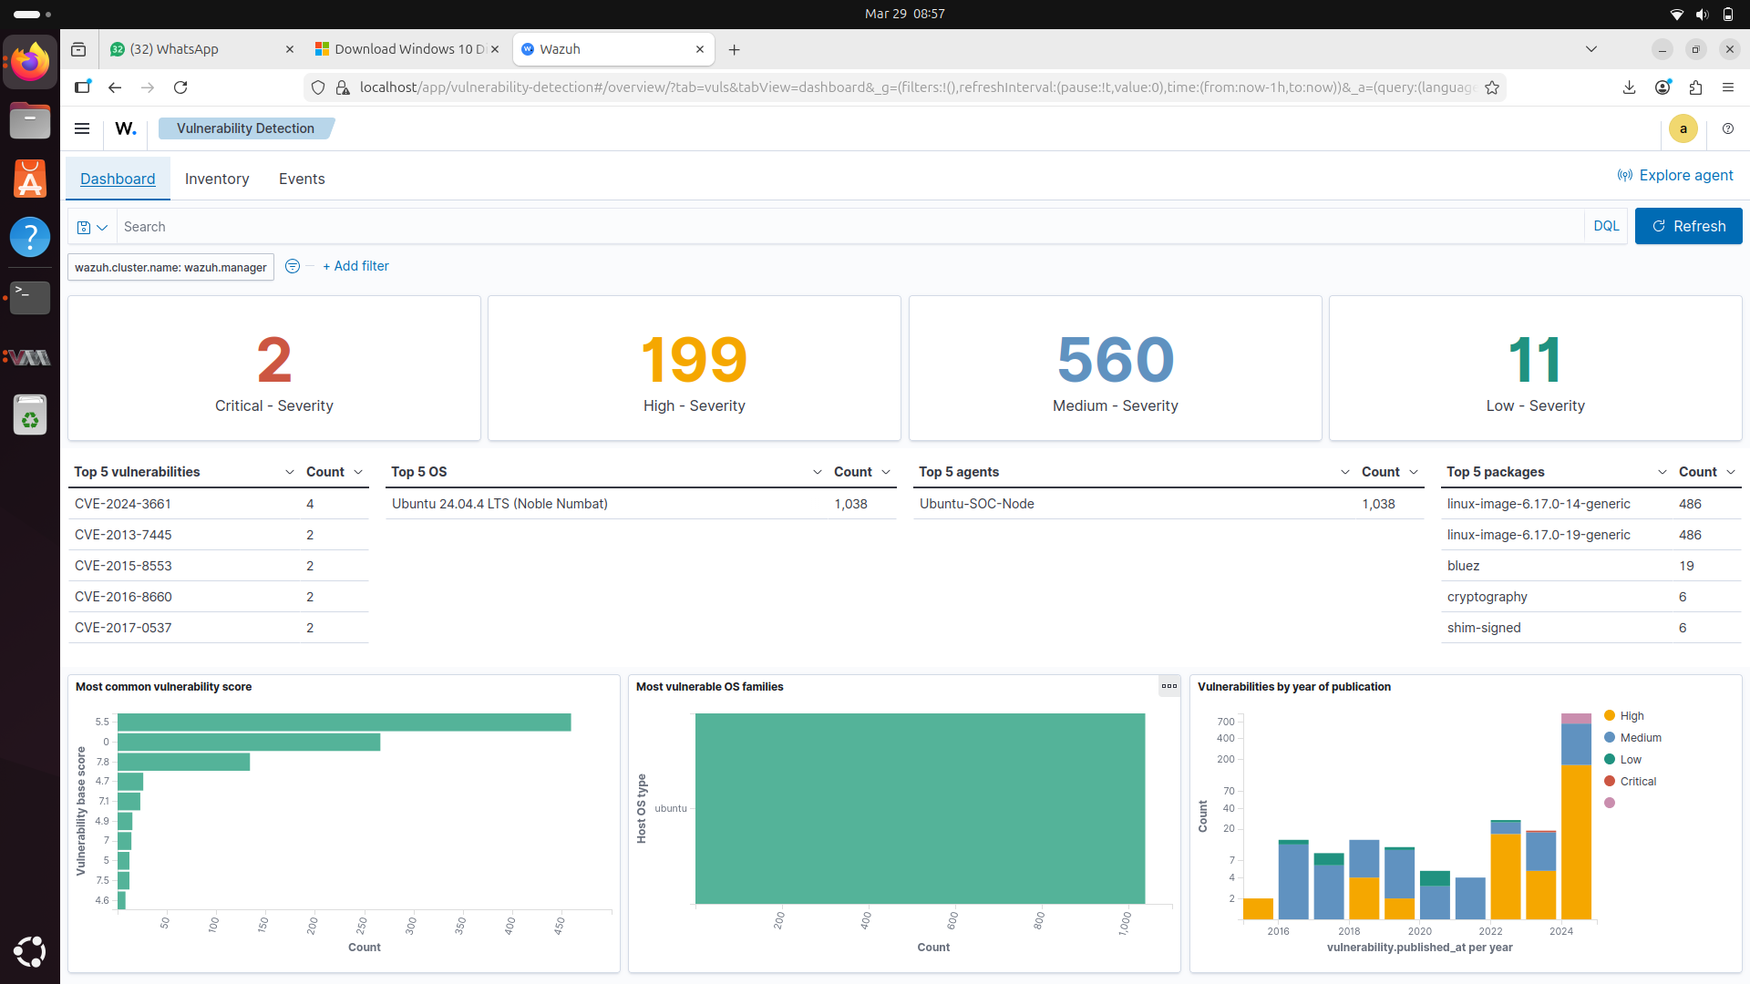
5. SOC DASHBOARDS & REPORTING (DAY 28)
​Objective: Transform raw security data into actionable intelligence for different audiences.

​5.1 Custom SOC Dashboard
​A high-visibility dashboard was constructed in Wazuh featuring:
​Alert Severity Breakdown: 7-day trend of alert levels.
​Agent Health: Real-time status of all lab endpoints.
​Top 10 Triggered Rules: Identifying the most frequent security events.
​Geographic Map: Visualizing the origin of source IPs.

​5.2 Multi-Level Reporting
​Technical SOC Summary: A deep-dive document for analysts, detailing authentication failures, FIM events, and specific NIDS alerts from Suricata.
​Executive Summary: A concise, jargon-free one-page report for management, highlighting the overall risk posture and key remediation recommendations (e.g., patching critical vulnerabilities found during scanning).

​

6. CONCLUSION
​By the end of Week 4, the internship has produced a functional, end-to-end security operations environment. The lab now encompasses Perimeter Defense (pfSense), Intrusion Detection (Wazuh/Suricata), Threat Intelligence (VirusTotal/MITRE), and Vulnerability Management. This foundation prepares the analyst for complex incident response and security architecture tasks in a professional SOC.

